Testing and Debugging in VC++
[or almost any of the Visual Studio environments…but each have their own peculiarities]

This tutorial will instruct you on how to test your program for correctness and use the debugger to debug your program in Visual C++.

Testing Fundamentals
There are two fundamental types of coding errors syntax errors and logical errors. Compiler or syntax errors are introduced by the programmer by either mistyping or not using the correct syntax. The other type of problem is commonly referred to as a “bug” or simply a “logical error” – these are errors that the programmer has introduced that result from the programmer not understanding the purpose of the program, misinterpreting the requirements or even misunderstanding how a code construct is used. We’ll discuss strategies for resolving both types of errors.

Syntax Errors
These are the easiest to fix (usually!) as they are caught by the compiler – so they’re also the easiest to detect and find. These types of errors sometimes appear as warnings or errors in the Build Window of VC++.

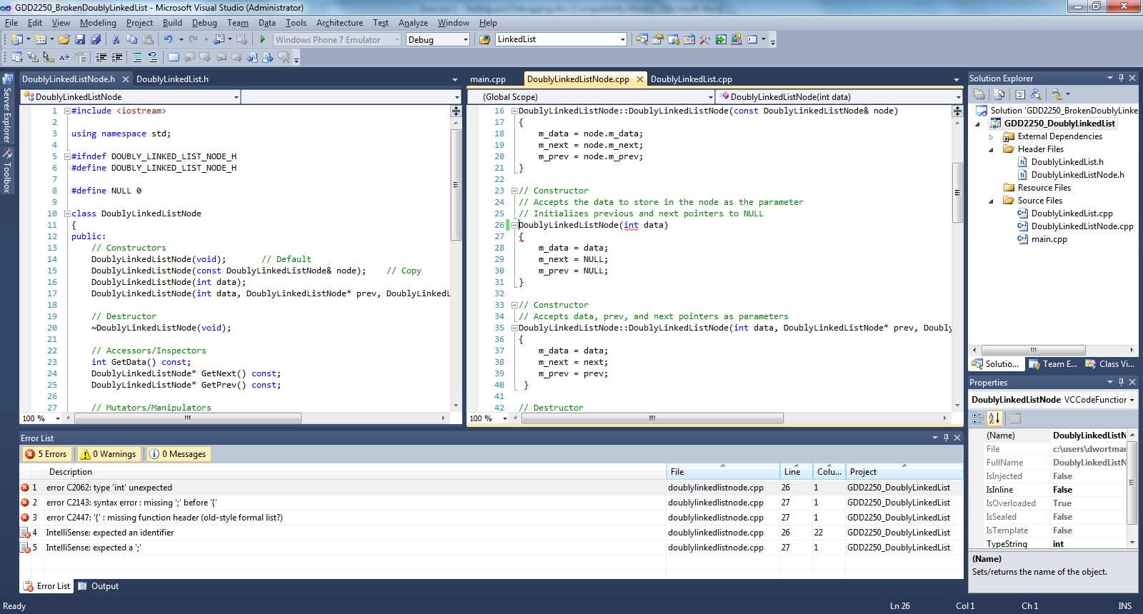

Each error or warning will be on its own line.
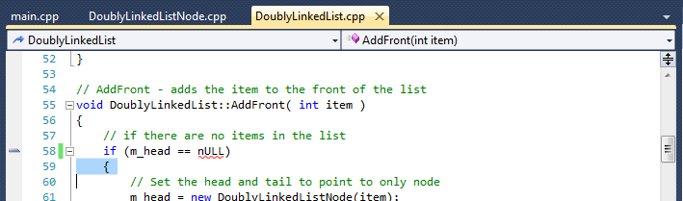

Double-clicking on the error will move your cursor the offending code, placing a green vertical bar to the left of the line(s).

Reviewing the error message in the build window, you can get an idea of what might be the problem. Unfortunately, the compiler can only tell you what it was expecting, not what you really did wrong. So, sometimes you have to look at the lines above the error to find out what is wrong.

One of the key strategies for getting rid of syntax errors is to always start with the first error (usually you can ignore warnings until you have gotten rid of all the errors, but we’ll discuss warnings in a bit). When you have multiple errors listed, many of them may be what we refer to as “waterfall errors” which means that when you solve the first one, the others disappear. This is because the C++ compiler, after finding an error, tries to continue to compile your code, getting very confused in the process. So, by solving the first error, you may get rid of many more!

Logical Errors
Logical errors are the most difficult to get rid of because they result from the programmer’s misconception of what the program should be doing. However, we can attempt to get rid of them by doing two things: (1) debug the application by stepping through each line of code and watching the variables change and (2) creating representative and boundary-exercising test cases and test suites.

Debugging in Visual C++
Visual C++ has quite a few tools to help you debug your applications. It provides you the ability to:
- Stop your application at any point (breakpoints)
- Run your application forward line by line (step into, over, out)
- View variables or objects at any point (watch variables)
- View the sequence of method calls with line numbers (call stack)

Inserting a Breakpoint
Breakpoints are used to stop the execution of your application at a specific line of code.
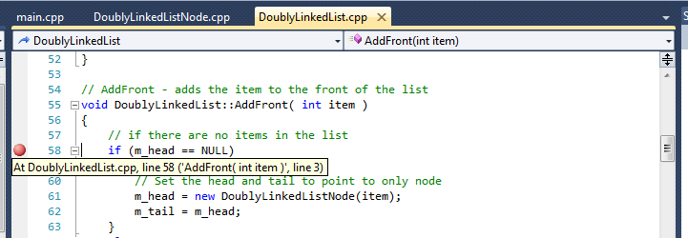

Click in the gray left-margin of your code window and a red circle will appear. Click it again to get rid of it. You can only place breakpoints on executable lines of code.

Whenever you run your code in Debug mode, it will stop at any breakpoints.

Stepping Through Code
Once your code has stopped at a breakpoint, you can then execute it line by line, until the next breakpoint, or until the end (if there are no more breakpoints). You can even step into, over, or out of methods.

Debugging Commands:
- Start Debugging (F5) – run until a breakpoint or in debug mode
- Step Into (F11) – jump into the method on this line, start from first line, or move forward one line
- Step Over (F10) – jump over the method on this line or start from first line
- Step Out (SHIFT + F11) – jump out of the current method (use this to get out of standard libraries or other code you didn’t write!)
- Stop Debugging (SHIFT + F5) – end this debugging session

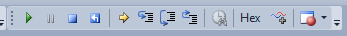

The Debug toolbar (when running in debug mode) has shortcuts for each of these operations.

Viewing Variables and Objects
While executing your code line by line, you have the opportunity to view the actual values of any variable, array, pointer, or data member on any line of code (where it is in scope and exists!). Unknown values are denoted by “???” which means the value was not initialized. Even bad pointers can be seen, if the system recognizes them, with the denotation “Bad Ptr”.

For the most part, the “Autos” tab will be sufficient as it automatically displays all variables in scope. However, there are also options for creating “Watches” which allow you to watch the value of different variables or expressions (yes, even an expression like an executable statement or Boolean expression!) as they change throughout the program.

Left-clicking the variable name and selecting “Add Watch” or “Quick Watch” or dragging it into the Watch window will watch that variable. This is useful if there are many variables in the Autos window and you’re only interested in a few. You must be debugging an application to have access to these features.

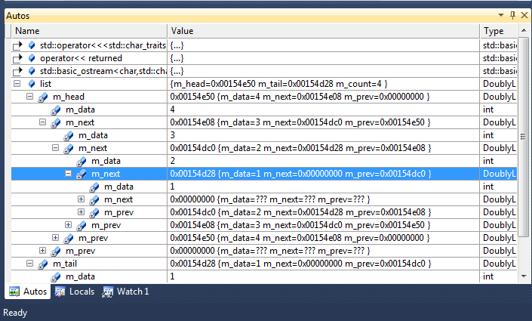

Debugging Exceptions
Exceptions can be the most difficult errors to find and remove. Usually because the line that throws the exception is often very different from the one that caused the exception in the first place. For example deleting a bad pointer will cause an exception, but it was in the creation of that memory in the first place where the error was introduced. You may have to “dig” through your code to figure out some of these errors.

Usually, exceptions are thrown and an “unhandled exception” error is displayed to the user. This is the WORST thing that could happen in a professional software product – your user should never know that you broke your code! Select “Break” and this will jump into your code at the point of the exception. The error message gives you an idea of what the problem is, but will be vague and difficult to relate back to your code…

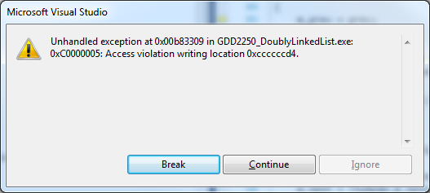

Start by looking at the line of code that caused the exception. There is a yellow arrow at the line of code that caused the exception and the Call Stack (bottom window) will show you the sequence of method calls that resulted in that line being executed. In this case, the exception was thrown by the AddFront() method when it called the SetPrev(). The exception message said “access violation writing location…” – this indicates that you have a dangling pointer (a pointer but no memory that it is pointing to!). In this case, you should begin looking at where your memory is created (do you have a “new” for every “delete”? Does your copy constructor do a deep copy? Does your assignment operator do a deep copy?).

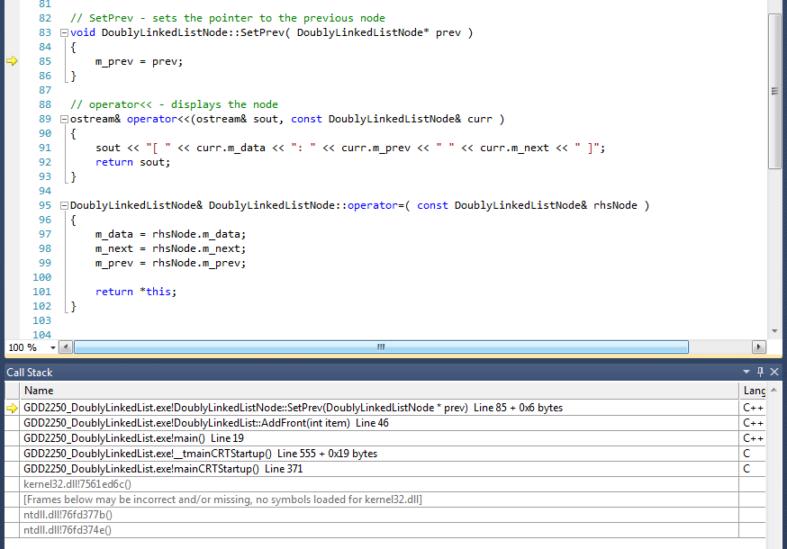

In some cases, the “Break” launches you into some standard library (like iostream). If this is the case, look through the Call Stack for the first instance of YOUR CODE and double-click on that line. This will give you the point in your code that triggered the exception and then work backwards from there.

Unfortunately, you can’t really “back-track” from the exception to figure out what is going on, but you can check variables at that moment and then figure out a good place to insert a breakpoint and then step forward from that point.

Debugging through Print statements
One sometimes faster strategy for debugging your application (versus using the debugger) is to simply print EVERYTHING. Print every variable, print every pointer, and print every object…over and over again until you figure out what is going wrong. I often use this in conjunction with the debugger as each is good for a variety of things. Don’t forget to take these debugging statements out before you release (or submit) your software…but they can be helpful. I even sometimes print messages like “Entering method X” and “leaving method X” so that I can see when methods are called and follow the logic in the code. This is especially helpful if you’re attempting to debug someone else’s code!

Warnings
At this point, you might be wondering about warnings – they allow your code to run (assuming you have no errors), so what do they do? Well, warnings can sometimes indicate logical errors – so it’s best to try and get rid of warnings. Unfortunately, most logical errors are still undetectable without extensive testing, so even getting rid of all the warnings and errors doesn’t ensure that your code is actually correct!

Testing Strategies
Developing test cases and test suites is one of the most important parts about developing solid, working code. Often, beginning programmers believe that once all the errors are gone, the code should be working fine. Well, unfortunately, since logical errors are so difficult to detect (and usually represent a programmer’s misunderstanding in the first place), we need to create many examples of possible inputs to fully “exercise” our code.

It would be nice if we could test every possible input to the system to ensure that no matter what a user does, the program will never crash. However, this is completely unrealistic, so instead, we attempt to find a representative sample that will hopefully hit most of the possible breaking points. One unfortunate truth about software that we must accept early in our careers is that it is nearly impossible to create “perfect” software – in fact, the number of bugs per line of code goes up exponentially as the number of lines of code increases. An independent review of Windows 2000 identified over 3000 programmer documented errors in the code that were not fixed (this says NOTHING about the errors that weren’t known…).

So, in order to attempt to make our software as good as possible, we develop test suites and test cases. A test case is a single example of a possible input to the system. Collections of these test cases are test suites. Developing good test suites can help you be pretty sure that your program is correct. There are two different views toward developing test cases, each has its strengths and weaknesses and so neither should be relied upon completely.

Black Box Testing
One of the methods for developing test cases is called “Black Box” testing, where the tester (in our case, the programmer) pretends that he/she knows nothing about how the code was written and can only see the interface. Test cases are developed by attempting to break the program by “blindly” trying different test cases. For example, if the program asks for an integer and the user types in a character instead, does the program break? These test cases can often be considered “stupid” cases in that the programmer must pretend that he/she is any “dumb” user in the world and so could supply the program with any possible input.

For example, if we were working on a Tic-Tac-Toe application and we had numbered rows and columns (1-3), we may test each of the following values for row and column:
- Values 1-3
- Values 0 and 4
- Characters/strings such as “one” or “a”
- Punctuation such as ; or :

In each case, the system should either prompt the user to correct their action or gracefully exit.

White Box Testing
The other method for developing test cases is called “White Box” or “Glass Box” testing, where the tester (in our case, the programmer) looks at the code and attempts to find weaknesses in the logic, physical representations, or accuracy of computations. White Box testing involves finding “Boundary Conditions” which are situations on the boundary of acceptable input/responses and could create a significant problem in the execution of the program. For example, if the program requests a positive integer from the user, it shouldn’t crash when the user enters a negative integer – nor should it crash when a zero is received – in any case, the program should either continue logically or gracefully exit. In this case zero or a negative integer could be considered a boundary condition and so should be part of our test suite.

For example, let us consider a Tic-Tac-Toe application. We know that the programmer has accepted the users input (for row and column) and stored it as a string. We know that there are several ways to translate a string into an int. One way would be to take only the first character of the input and convert it to an integer. Or, we may know that floating point values can be read as “int” “dot” “int”. So these might be something we want to test for. So we would expand our testing suite to include the following tests:
- Values with multiple digits where first digit works: “10” or “31” or “2342351”
- Values with valid integers at beginning: 1.1254, 1231.125412
- Values with valid integers followed by chars: 123asdf, 234asfg

Let’s consider another example. Say we ask the user for their age. Valid values are assumed to be 1-125. Considering that the programmer’s code probably has something like this: if (x >= 1 && x <= 125), we understand that this could have several problems – what if the programmer forgot the “=” symbol? That would dramatically change the logic! So, we may consider “boundary” values at and around each boundary and within each “range” for this value:
- 0, 1, 2 (lower boundary test)
- 124, 125, 126 (upper boundary test)
- 75 (middle value test)
- -75 (low value test)
- 200 (high value test)

Developing a Test Suite
The key to a good test suite is that it covers enough of the possible set of inputs/outputs without over-covering any portion. You don’t necessarily need hundreds of acceptable inputs, a few “good examples” should suffice, but you do need to be sure to look for boundary conditions – try and find when and under what conditions the program would collapse and do something wrong. These are the conditions where the program is most likely to perform poorly!

As you can see, even testing a simple class may take 100s of test cases! The Windows NT daily test suite took 4 hours to run its “validity” set of tests on the Windows NT operating system. The C++ compiler, took 8 hours to run its complete test suite (1000s of code files are compiled). Both of these systems ran their tests every night on every check-in of code!

Using a Test Suite
For this project you will be using a test suite that has already been developed. This test suite uses the Assert library to compare the actual results from running your code with the expected results. If these two match, the test passes. If they do not, the test fails. Assert statements have the following format (usually, but there may be some variation):

Assert::ComparisonMethod(expected result, actual result,
error message, line info)

Let’s look at a simple example:

TEST_METHOD(Constructor)
{
DoublyLinkedList list;
// The "L" that prefixes the string means that the string is stored
// as 16-bit characters instead of 8-bit characters and is
// required by the assert
Assert::AreEqual(0, list.GetCount(), L"Constructor Count Incorrect",
LINE_INFO());
Assert::AreEqual(NULL, (int)list.GetHead(),
L"Constructor Head Incorrect", LINE_INFO());
Assert::AreEqual(NULL, (int)list.GetTail(),
L"Constructor Tail Incorrect", LINE_INFO());
Assert::AreEqual(0, DoublyLinkedListNode::GetNbrOfNodes(),
L"Constructor GetNbrOfNodes Incorrect", LINE_INFO());

stream << list;
actualResult = stream.str();
expectedResult = "EMPTY LIST";
Assert::AreEqual(expectedResult, actualResult,
L"Constructor Output Incorrect", LINE_INFO());
}

This example tests the Constructor of a DoublyLinkedList. The title of the test is indicated in the TEST_METHOD line (this is how the system will indicate which tests pass/fail):

TEST_METHOD(Constructor)

Let’s look at each section:

Assert::AreEqual(0, list.GetCount(), L"Constructor Count Incorrect",
LINE_INFO());

Here, we check to see if the count is zero when a list is first constructed (therefore, the list is empty).

Assert::AreEqual(NULL, (int)list.GetHead(),
L"Constructor Head Incorrect", LINE_INFO());

Here, we check to see if the head is initialized to NULL.

Assert::AreEqual(NULL, (int)list.GetTail(),
L"Constructor Tail Incorrect", LINE_INFO());

Here, we check to see if the tail is initialized to NULL.

Assert::AreEqual(0, DoublyLinkedListNode::GetNbrOfNodes(),
L"Constructor GetNbrOfNodes Incorrect", LINE_INFO());

Here, we check to see that zero nodes have been constructed.

stream << list;
actualResult = stream.str();
expectedResult = "EMPTY LIST";
Assert::AreEqual(expectedResult, actualResult,
L"Constructor Output Incorrect", LINE_INFO());

Here, we check to see that when we attempt to print the list, the output says that the list is empty.

You’ll see that all of the tests are formatted in this way, with a collection of assertions. When the tests are run, if a single assertion fails, the entire test fails and only the FIRST assertion that fails is reported (no others are even executed). So, when a test fails, start with the first instance of an assertion that fails to try and figure out which one failed – you can comment them out temporarily to figure out which section failed, but be sure to look carefully at the report from Visual Studio to determine which assertion failed.

Running the Test Suite
Thankfully, it is really east to run the test suite (but it might take up to a minute to get the results). Select the menu TEST -> Run -> All Tests. Once you’ve run the test suite once, you can run a subset of tests based on what you’re working on such as an individual test (selected tests), all failed tests, all passed tests, or repeat the last run of tests.
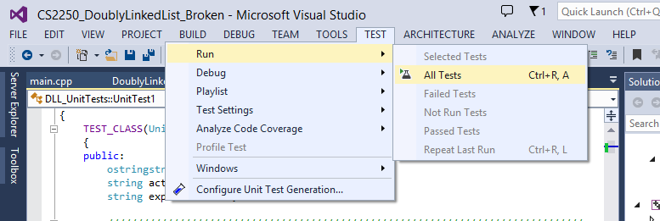

Once you’ve run the test suite, Visual Studio will pop up a new window (it might take a minute the first time…) called Test Explorer – this will have the results from all of the tests. Initially, your application fails all of the tests (below):

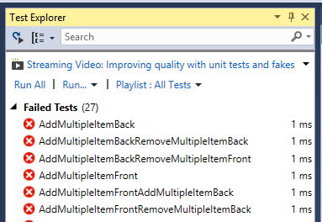

You can click on each of these and get information about the error. Initially, this will not be very helpful as all of the tests have failed with the vague message “Exception Code: CXXXXXXX”. This means that your code has thrown an exception, which means that somewhere, some bad memory is being accessed. This is where you’ll want to jump into using main (and the usual Local Windows Debugger) to figure out what is going on. Here is what you’ll find when you run Main:

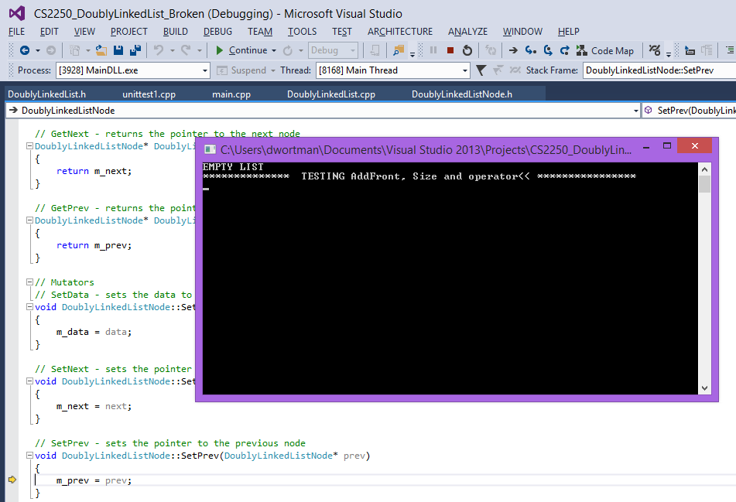

This is where the exception breaks your application – in the SetPrev method. Since I promised you that no bugs are in the Node class, it’s how the List uses this method that must be creating a problem – somewhere we have a pointer that should be NULL, but isn’t! Since main displayed the list correctly after constructing it (“EMPTY LIST”), at least something there is working! But something bad happens after that. Let’s look at main and see if we can figure out what’s going on…

Below is the code in main. It constructs the list correctly and then prints it out, so at least we know that those two pieces seem to be working. It then prints the “TESTING” message, but then fails after that point. It SHOULD be printing the size of the list and then the list itself and then the all of the Node data (PrintFullNodes), but doesn’t get to any of this.
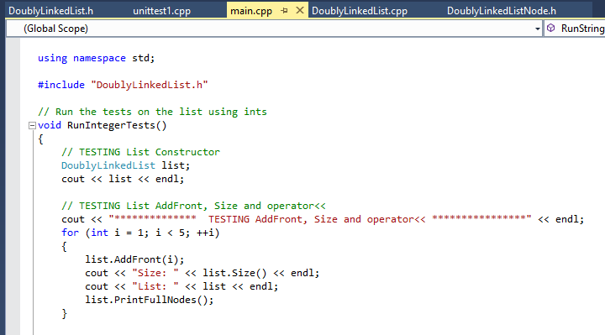

Since the AddFront method is likely the culprit, start by putting a breakpoint on the list.AddFront(i) method call, run your application again, and STEP INTO this method. See if you can figure out what’s going on here…

Later, as you correct these initial errors, your code will start to pass tests. You can get more information about why a test is failing by looking at the detailed information about the test:
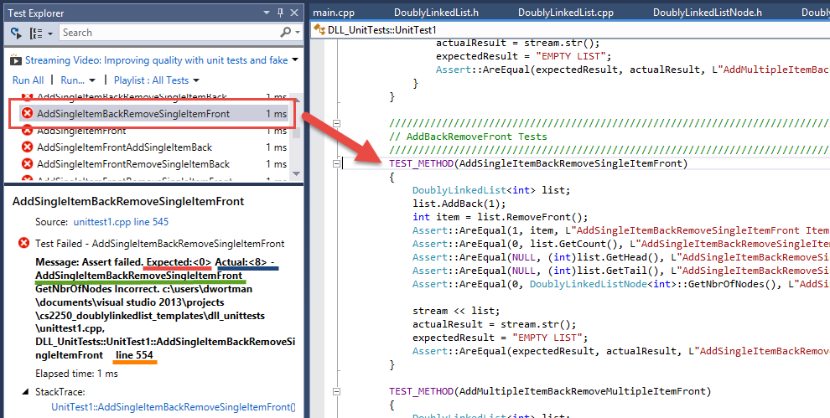

If you click on a test name that failed (red box), it will bring up the detail in the bottom window with the Expected result (red underline), the Actual result (blue underline), the name of the test (green underline), and the line number in the testing file (orange underline) of the Assert that failed.

If you double-click on the test name that failed, Visual Studio will bring the failed test into the main window.

In this case, the Assert that failed is:

Assert::AreEqual(0, DoublyLinkedListNode<int>::GetNbrOfNodes(),
L"AddSingleItemBackRemoveSingleItemFront GetNbrOfNodes Incorrect",
LINE_INFO());

This tells us that something is wrong with the number of nodes that has been created – we expected 0 nodes but somehow got 8 nodes!! Ack! This could indicate we have a memory leak or we are accessing bad data somehow…

Back to main to try and figure out what happened…

Use the debugger in conjunction with main and your tests to watch values change, check for initialization, and explore various scenarios.

